Asymmetric DCC correlation: USDCAD and EURGBP
Method 10 / GARCH(1,1) + Cappiello-Engle-Sheppard ADCC / Alpari D1 full available history

Study setup
Logical pair: USDCAD , EURGBP
Broker symbols: USDCAD_i , EURGBP_i
Snapshot: 2026-11-03_majors_alpari_D1
Timeframe: D1
Matched return window: 1999-01-06 to 2026-11-02 (UTC bar dates)
Matched return count n: 7185
Dropped unfinished last bar dated 2026-11-03 UTC after a tick-volume check against the prior complete day.
USDCAD GARCH(1,1): mu=-0.000001, omega=0.001256, alpha=0.043641, beta=0.951263
EURGBP GARCH(1,1): mu=-0.000026, omega=0.000657, alpha=0.046408, beta=0.951884
ADCC: a=0.008267, b=0.988966, g=0.003299, a+b+g/2=0.998882
Nested DCC (g=0): a=0.008672, b=0.989217
Negative shock: n = min(z, 0) in broker quote direction (not inverted)
Burn-in ignored in path summaries and chart: first 60 updates
Complete matched rows (Excel): USDCAD-EURGBP_ADCC_D1.xlsx
Complete matched rows (HTML table): USDCAD-EURGBP_ADCC_D1_data.html

Method carried forward
Asymmetric DCC extends Engle DCC with an extra term on joint negative standardised shocks. Each matched daily log return of close, ln(close_t / close_t-1), is first filtered by a constant-mean GARCH(1,1). Then z = residual / sigma and n = min(z, 0). The Cappiello-Engle-Sheppard recursion uses A = (1-a-b) Q_bar - g N_bar with N_bar = mean(n n'). Quotes are not inverted, so a negative shock is a negative log return in the broker quote. Nested symmetric DCC (g = 0) is fit on the same z path for comparison. Constraints: a,b,g >= 0 and a + b + g/2 < 1. Path summaries ignore the first 60 updates. The headline is latest ADCC rho. Pearson r is a side check only. This is not a cause, lead, or trading signal.

Results
Latest ADCC rho: 0.012785
Latest nested DCC rho: 0.016929
Post-burn-in ADCC path (n=7125): mean=-0.021606, median=-0.032111, min=-0.345589, max=0.309218, std=0.136313
Share of post-burn-in days with |rho| >= 0.4: 0.00%; |rho| >= 0.7: 0.00%
Same-sample Pearson r: -0.014622
ADCC minus r: 0.027407
ADCC minus nested DCC: -0.004144

Conclusion
Over 7185 matched daily log-return rows for USDCAD and EURGBP (broker quote directions unchanged), latest ADCC rho is 0.0128 (positive, weak conditional linear link in this sample) with fitted a=0.0083, b=0.9890, g=0.0033. Nested symmetric DCC latest rho is 0.0169 (ADCC minus DCC = -0.0041). After a 60-day burn-in, path mean is -0.0216 and std is 0.1363. Same-sample Pearson r is -0.0146 (ADCC minus r = 0.0274). This does not establish cause, lead-lag, or a lasting trading rule.

Charts
Daily closes

Daily log returns
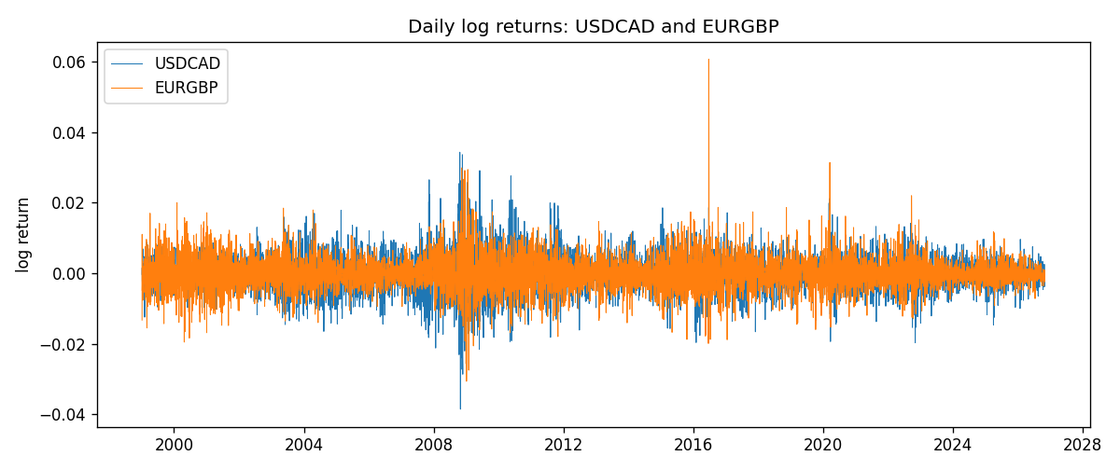
ADCC rho path with nested DCC and Pearson r
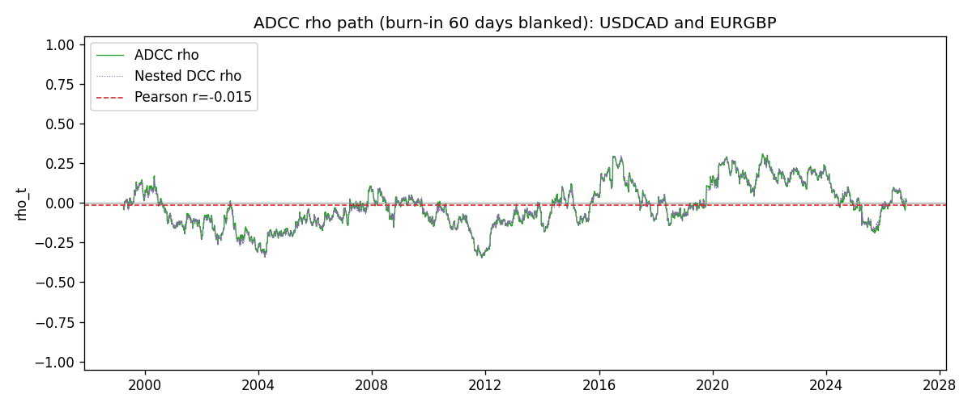

Data report
Every matched row that entered the ADCC recursion is stored in the sibling Excel workbook named USDCAD-EURGBP_ADCC_D1.xlsx. Embedding all rows as a Word table is impractical at this length; the Word file holds the column list, column summaries, and the first and last 15 matched rows.
Columns: time, USDCAD_open, EURGBP_open, USDCAD_high, EURGBP_high, USDCAD_low, EURGBP_low, USDCAD_close, EURGBP_close, USDCAD_tick_volume, EURGBP_tick_volume, USDCAD_spread, EURGBP_spread, USDCAD_real_volume, EURGBP_real_volume, USDCAD_log_return, EURGBP_log_return, USDCAD_sigma, EURGBP_sigma, USDCAD_z, EURGBP_z, USDCAD_n, EURGBP_n, q11, q22, q12, rho_adcc, rho_dcc
Column summaries (matched calculation rows)
column | count | mean | std | min | 25% | 50% | 75% | max
USDCAD_open | 7185 | 1.2666594 | 0.16886861 | 0.9168 | 1.1183 | 1.29841 | 1.37203 | 1.6183
EURGBP_open | 7185 | 0.78693389 | 0.09666561 | 0.5734 | 0.6876 | 0.83387 | 0.86521 | 0.9769
USDCAD_high | 7185 | 1.2715589 | 0.16882635 | 0.9336 | 1.1227 | 1.30381 | 1.3764 | 1.619
EURGBP_high | 7185 | 0.79000929 | 0.09704455 | 0.5789 | 0.6896 | 0.8369 | 0.8681 | 0.9799
USDCAD_low | 7185 | 1.2621046 | 0.16891061 | 0.9056 | 1.11396 | 1.29347 | 1.36776 | 1.6102
EURGBP_low | 7185 | 0.78423344 | 0.09648411 | 0.5682 | 0.6855 | 0.83166 | 0.86287 | 0.9661
USDCAD_close | 7185 | 1.2666836 | 0.16885076 | 0.916 | 1.118 | 1.29833 | 1.3723 | 1.6137
EURGBP_close | 7185 | 0.78697576 | 0.09666885 | 0.5735 | 0.6878 | 0.83391 | 0.86533 | 0.977
USDCAD_tick_volume | 7185 | 81049.359 | 147325.09 | 37 | 5563 | 40946 | 71633 | 1410818
EURGBP_tick_volume | 7185 | 87109.869 | 145486.28 | 154 | 6553 | 44326 | 81375 | 1424684
USDCAD_spread | 7185 | 23.430202 | 18.259258 | 0 | 9 | 17 | 40 | 60
EURGBP_spread | 7185 | 21.335421 | 19.123862 | 0 | 4 | 13 | 40 | 50
USDCAD_real_volume | 7185 | 1.8384377e+10 | 9.670755e+10 | 0 | 0 | 0 | 0 | 2.5751613e+12
EURGBP_real_volume | 7185 | 2.7864528e+10 | 1.3519652e+11 | 0 | 0 | 0 | 0 | 3.5726265e+12
USDCAD_log_return | 7185 | -8.08e-06 | 0.00514591 | -0.03859748 | -0.00283484 | 5.597e-05 | 0.00272835 | 0.03436319
EURGBP_log_return | 7185 | 1.874e-05 | 0.00486681 | -0.03067367 | -0.00262366 | -0.00010035 | 0.00255918 | 0.06075387
USDCAD_sigma | 7185 | 0.00479602 | 0.00181736 | 0.00251056 | 0.00365045 | 0.00435032 | 0.00535867 | 0.01852984
EURGBP_sigma | 7185 | 0.0046283 | 0.00169323 | 0.00185771 | 0.0034331 | 0.00440574 | 0.00551675 | 0.01546402
USDCAD_z | 7185 | 0.00155166 | 1.0001171 | -4.070538 | -0.62801875 | 0.01104937 | 0.61223531 | 6.4145566
EURGBP_z | 7185 | 0.0081884 | 1.0000657 | -3.7918388 | -0.62167863 | -0.01834419 | 0.59954915 | 8.4871852
USDCAD_n | 7185 | -0.38696243 | 0.58857789 | -4.070538 | -0.62801875 | 0 | 0 | 0
EURGBP_n | 7185 | -0.37962168 | 0.57078443 | -3.7918388 | -0.62167863 | -0.01834419 | 0 | 0
q11 | 7185 | 1.0022412 | 0.1095001 | 0.74159892 | 0.92606397 | 0.99307535 | 1.062872 | 1.4949991
q22 | 7185 | 1.0027009 | 0.10470792 | 0.75459676 | 0.9349866 | 0.99473555 | 1.0617392 | 1.7541587
q12 | 7185 | -0.02110898 | 0.1397294 | -0.4043651 | -0.11663831 | -0.03002142 | 0.06839022 | 0.41305294
rho_adcc | 7185 | -0.02136333 | 0.13577256 | -0.34558904 | -0.11912441 | -0.03060923 | 0.07271345 | 0.30921783
rho_dcc | 7185 | -0.02189986 | 0.1356203 | -0.34965517 | -0.11617366 | -0.03118665 | 0.07188718 | 0.29653514
First 15 matched rows (selected columns)
time | USDCAD_log_return | EURGBP_log_return | USDCAD_z | EURGBP_z | USDCAD_n | EURGBP_n | q11 | q22 | q12 | rho_adcc | rho_dcc
1999-01-06 | -0.0003306769 | -0.013303338 | -0.085350369 | -2.3691739 | -0.085350369 | -2.3691739 | 1 | 1 | -0.020722571 | -0.020722571 | -0.020722571
1999-01-07 | 0.0015202092 | 0.011051402 | 0.40191362 | 1.7935132 | 0 | 0 | 0.9901805 | 1.0551022 | -0.018670163 | -0.018266009 | -0.018504104
1999-01-08 | -0.0020495197 | -0.004943862 | -0.55038335 | -0.75827505 | -0.55038335 | -0.75827505 | 0.98172054 | 1.0712701 | -0.013019827 | -0.01269585 | -0.012126396
1999-01-11 | -0.0035137769 | -0.0012752393 | -0.95652279 | -0.19460495 | -0.95652279 | -0.19460495 | 0.97552206 | 1.0673167 | -0.0085642142 | -0.0083930986 | -0.0085358387
1999-01-12 | 0.0066194721 | 0.0033970309 | 1.8022722 | 0.54535909 | 0 | 0 | 0.97647048 | 1.0571947 | -0.0068317828 | -0.006723989 | -0.0069286648
1999-01-13 | 0.0045420214 | 0.00042381861 | 1.1779354 | 0.072810727 | 0 | 0 | 0.99367981 | 1.0492053 | 0.00085433168 | 0.00083670631 | 0.0015225904
1999-01-14 | 0.0069376546 | -0.0019793588 | 1.7811396 | -0.3240814 | 0 | -0.3240814 | 0.99531682 | 1.038889 | 0.0010389563 | 0.0010217203 | 0.0021997013
1999-01-15 | -0.0056905671 | -0.0076715819 | -1.3938212 | -1.2954139 | -1.3938212 | -1.2954139 | 1.0116921 | 1.0298575 | -0.0042596246 | -0.0041730979 | -0.0027825214
1999-01-18 | 0.00098344542 | 0.00071280921 | 0.23607177 | 0.12317376 | 0 | 0 | 1.0241289 | 1.0391196 | 0.01615552 | 0.015660689 | 0.012461114
1999-01-19 | 0.002748513 | -0.0014261269 | 0.67262399 | -0.23912697 | 0 | -0.23912697 | 1.0144196 | 1.0289962 | 0.015702649 | 0.01536941 | 0.0126361
1999-01-20 | -0.0059646885 | 0.0019960086 | -1.4748639 | 0.35294875 | -1.4748639 | 0 | 1.0080971 | 1.0195205 | 0.013684662 | 0.013498482 | 0.011161009
1999-01-21 | -0.0042823796 | -0.00071240297 | -1.0314016 | -0.12239736 | -1.0314016 | -0.12239736 | 1.0232624 | 1.0105178 | 0.0087151522 | 0.0085705656 | 0.0065306016
1999-01-22 | 0.0025057712 | -0.0017118406 | 0.60238578 | -0.30756752 | 0 | -0.30756752 | 1.0254057 | 1.0007579 | 0.0095640797 | 0.0094412789 | 0.0075285486
1999-01-25 | 0.00085579808 | -0.0054402425 | 0.20858021 | -1.0088047 | 0 | -1.0088047 | 1.0182215 | 0.99202646 | 0.0074118459 | 0.0073746875 | 0.005851344
1999-01-26 | 0.0001973879 | -0.00057438255 | 0.049271675 | -0.10217001 | 0 | -0.10217001 | 1.0084763 | 0.99406778 | 0.005075503 | 0.0050691861 | 0.0039400006
Last 15 matched rows (selected columns)
time | USDCAD_log_return | EURGBP_log_return | USDCAD_z | EURGBP_z | USDCAD_n | EURGBP_n | q11 | q22 | q12 | rho_adcc | rho_dcc
2026-10-13 | -0.0046395653 | 0.00020130374 | -1.6070736 | 0.11269292 | -1.6070736 | 0 | 0.82723843 | 0.79304428 | -0.037728372 | -0.046580484 | -0.028453481
2026-10-14 | 0.0015184751 | 0.0011241873 | 0.50677696 | 0.58017498 | 0 | 0 | 0.84911214 | 0.78561576 | -0.039324299 | -0.048147459 | -0.029974295
2026-10-15 | -0.0036101503 | -0.00087557391 | -1.2181917 | -0.43230007 | -1.2181917 | -0.43230007 | 0.84299655 | 0.78094698 | -0.036974653 | -0.045570148 | -0.026729284
2026-10-16 | -0.0034322068 | -0.0020380844 | -1.1409578 | -1.0352604 | -1.1409578 | -1.0352604 | 0.85198896 | 0.77570844 | -0.030990761 | -0.038121151 | -0.020888767
2026-10-19 | -0.0018835331 | -0.00056950988 | -0.61922932 | -0.27717081 | -0.61922932 | -0.27717081 | 0.85877477 | 0.78076215 | -0.017502262 | -0.021374461 | -0.0081287797
2026-10-20 | -0.0037066008 | -0.0035906254 | -1.2302732 | -1.8422555 | -1.2302732 | -1.8422555 | 0.85486425 | 0.77425271 | -0.015839046 | -0.019468795 | -0.0063154212
2026-10-21 | -0.00084691787 | -0.00140647 | -0.2765785 | -0.67218674 | -0.2765785 | -0.67218674 | 0.86406784 | 0.80618018 | 0.010034627 | 0.012022956 | 0.017498879
2026-10-22 | -0.0026307268 | -0.0018743924 | -0.87387563 | -0.90522761 | -0.87387563 | -0.90522761 | 0.85654876 | 0.80372761 | 0.011559152 | 0.013931423 | 0.019304395
2026-10-23 | 2.85545e-05 | 0.00082421033 | 0.0098206621 | 0.41493519 | 0 | 0 | 0.85706032 | 0.80555376 | 0.0200659 | 0.024149363 | 0.027351854
2026-10-26 | 5.7106554e-05 | 0.00013133309 | 0.019661554 | 0.077587521 | 0 | 0 | 0.84873463 | 0.79930559 | 0.019363175 | 0.023509002 | 0.02724513
2026-10-27 | 0.0025379458 | -0.0019957343 | 0.87459707 | -0.98977727 | 0 | -0.98977727 | 0.8405032 | 0.79175275 | 0.018647128 | 0.022858487 | 0.027135814
2026-10-28 | -0.0038379274 | 0.00066967224 | -1.3220383 | 0.34690389 | -1.3220383 | 0 | 0.83868316 | 0.79556415 | 0.010769803 | 0.013184729 | 0.017532113
2026-10-29 | -0.00011436495 | -0.0011722209 | -0.038265059 | -0.57972099 | -0.038265059 | -0.57972099 | 0.85077419 | 0.78899773 | 0.0063444549 | 0.0077437137 | 0.012384052
2026-10-30 | -0.0010298736 | -0.0024205543 | -0.35334508 | -1.220517 | -0.35334508 | -1.220517 | 0.84253399 | 0.7853959 | 0.0060160178 | 0.0073955603 | 0.012511887
2026-11-02 | 0.00061519094 | 0.00089940465 | 0.21468384 | 0.46268846 | 0 | 0 | 0.83581182 | 0.79517609 | 0.010422598 | 0.012784687 | 0.016928759

